**Machine Learning -ID3 Algorithm Decision Tree – Solved Example**

Build a **decision tree**using ID3 algorithm for the given training data in the table (Buy Computer data), and predict the class of the following new example: **age<=30, income=medium, student=yes, credit-rating=fair**

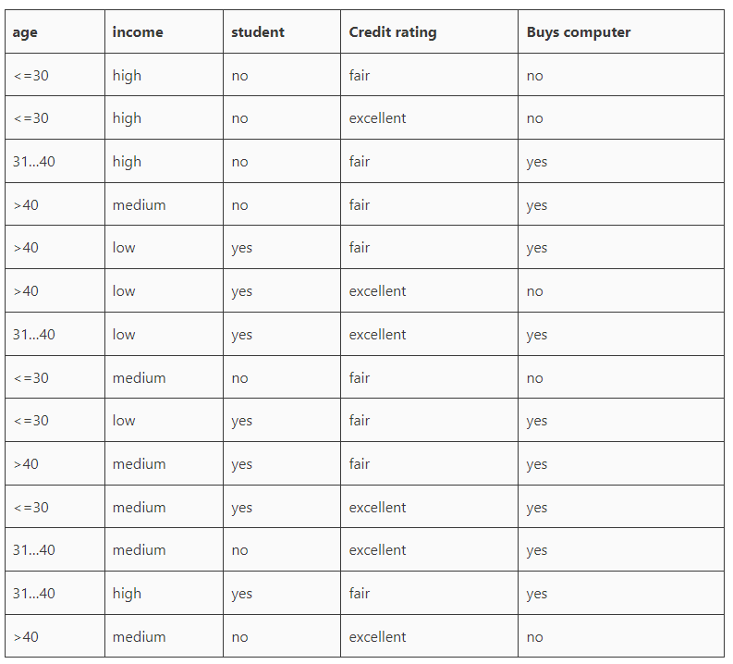

### Solution:

Information gain is **a measure used to determine which feature should be used to split the data** at each internal node of the decision tree.

First, check which attribute provides the highest Information Gain in order to split the training set based on that attribute. We need to calculate the expected information to classify the set and the entropy of each attribute.

The information gain is this mutual information minus the entropy:

The mutual information of the two classes,

Entropy(S)= E(9,5)= -9/14 log2(9/14) – 5/14 log2(5/14)=0.94



**Now Consider the Age attribute**

For Age, we have three values age<=30 (2 yes and 3 no), age31..40 (4 yes and 0 no), and age>40 (3 yes and 2 no)

Entropy(age) = 5/14 (-2/5 log2(2/5)-3/5log2(3/5)) + 4/14 (0) + 5/14 (-3/5log2(3/5)-2/5log2(2/5))

= 5/14(0.9709) + 0 + 5/14(0.9709) = 0.6935

Gain(age) = 0.94 – 0.6935 = 0.2465

**Next, consider Income Attribute**

For Income, we have three values incomehigh (2 yes and 2 no), incomemedium (4 yes and 2 no), and incomelow (3 yes 1 no)

Entropy(income) = 4/14(-2/4log2(2/4)-2/4log2(2/4)) + 6/14 (-4/6log2(4/6)-2/6log2(2/6)) + 4/14 (-3/4log2(3/4)-1/4log2(1/4))

= 4/14 (1) + 6/14 (0.918) + 4/14 (0.811)

= 0.285714 + 0.393428 + 0.231714 = 0.9108

Gain(income) = 0.94 – 0.9108 = 0.0292

**Next, consider Student Attribute**

For Student, we have two values studentyes (6 yes and 1 no) and studentno (3 yes 4 no)

Entropy(student) = 7/14(-6/7log2(6/7)-1/7log2(1/7)) + 7/14(-3/7log2(3/7)-4/7log2(4/7)

= 7/14(0.5916) + 7/14(0.9852)

= 0.2958 + 0.4926 = 0.7884

Gain (student) = 0.94 – 0.7884 = 0.1516

**Finally, consider Credit_Rating** **Attribute**

For Credit_Rating we have two values credit_ratingfair (6 yes and 2 no) and credit_ratingexcellent (3 yes 3 no)

Entropy(credit_rating) = 8/14(-6/8log2(6/8)-2/8log2(2/8)) + 6/14(-3/6log2(3/6)-3/6log2(3/6))

= 8/14(0.8112) + 6/14(1)

= 0.4635 + 0.4285 = 0.8920

Gain(credit_rating) = 0.94 – 0.8920 = 0.479

**Since Age has the highest Information Gain we start splitting the dataset using the age attribute.**

[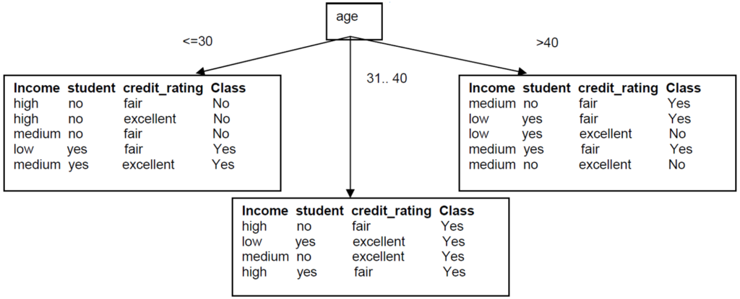](https://vtupulse.com/wp-content/uploads/2023/01/image.png)

Decision Tree after step 1

Since all records under the branch age31..40 are all of the class, Yes, we can replace the leaf with Class=Yes



[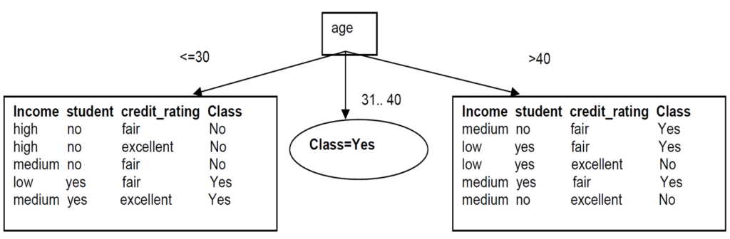](https://vtupulse.com/wp-content/uploads/2023/01/image-1.png)Decision Tree after step 1_1



### Now build the decision tree for the left subtree

**The same process of splitting has to happen for the two remaining branches.**

[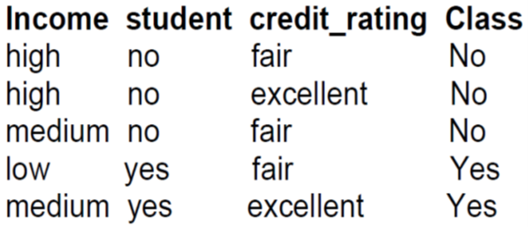](https://vtupulse.com/wp-content/uploads/2023/01/image-2.png)Left sub-branch

For branch age<=30 we still have attributes income, student, and credit_rating. Which one should be used to split the partition?

The mutual information is E(Sage<=30)= E(2,3)= -2/5 log2(2/5) – 3/5 log2(3/5)=0.97

For **Income,**we have three values incomehigh (0 yes and 2 no), incomemedium (1 yes and 1 no) and incomelow (1 yes and 0 no)

Entropy(income) = 2/5(0) + 2/5 (-1/2log2(1/2)-1/2log2(1/2)) + 1/5 (0) = 2/5 (1) = 0.4

Gain(income) = 0.97 – 0.4 = 0.57

For **Student,**we have two values studentyes (2 yes and 0 no) and studentno (0 yes 3 no)

Entropy(student) = 2/5(0) + 3/5(0) = 0

Gain (student) = 0.97 – 0 = 0.97



We can then safely split on attribute student without checking the other attributes since the information gain is maximum (i.e. Gain cannot be more than H(S)).

[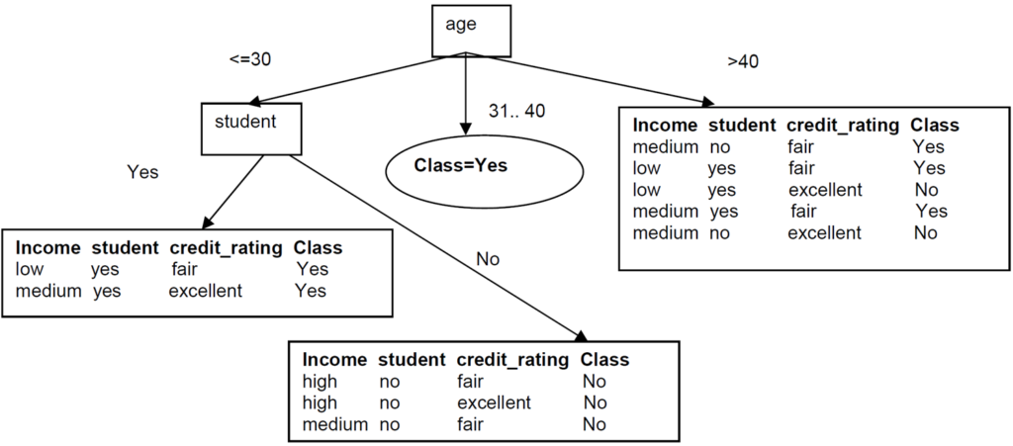](https://vtupulse.com/wp-content/uploads/2023/01/image-6.png)Decision Tree after step 2



Since these two new branches are from distinct classes, we make them into leaf nodes with their respective class as label:

[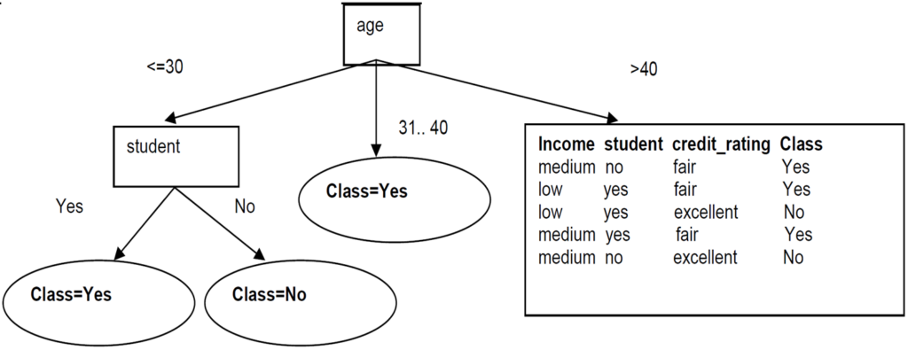](https://vtupulse.com/wp-content/uploads/2023/01/image-5.png)Decision Tree after step 2_2

### Now build the decision tree for right left subtree

[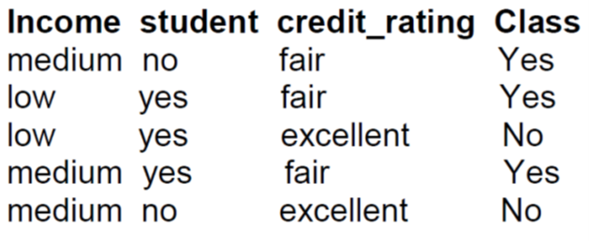](https://vtupulse.com/wp-content/uploads/2023/01/image-8.png)Right sub-branch

The mutual information is Entropy(Sage>40)= I(3,2)= -3/5 log2(3/5) – 2/5 log2(2/5)=0.97

For **Income**, we have two values incomemedium (2 yes and 1 no) and incomelow (1 yes and 1 no)

Entropy(income) = 3/5(-2/3log2(2/3)-1/3log2(1/3)) + 2/5 (-1/2log2(1/2)-1/2log2(1/2))

= 3/5(0.9182)+2/5 (1) = 0.55+0. 4= 0.95

Gain(income) = 0.97 – 0.95 = 0.02

For **Student**, we have two values studentyes (2 yes and 1 no) and studentno (1 yes and 1 no)

Entropy(student) = 3/5(-2/3log2(2/3)-1/3log2(1/3)) + 2/5(-1/2log2(1/2)-1/2log2(1/2)) = 0.95

Gain (student) = 0.97 – 0.95 = 0.02

For **Credit_Rating**, we have two values credit_ratingfair (3 yes and 0 no) and credit_ratingexcellent (0 yes and 2 no)

Entropy(credit_rating) = 0

Gain(credit_rating) = 0.97 – 0 = 0.97

We then split based on credit_rating. These splits give partitions each with records from the same class. We just need to make these into leaf nodes with their class label attached:



[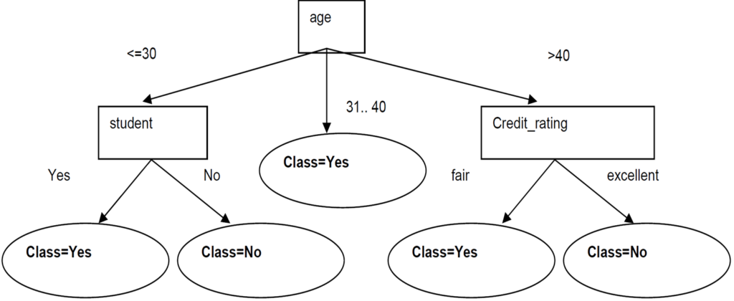](https://vtupulse.com/wp-content/uploads/2023/01/image-7.png)Decision Tree for Buys Computer

New example: age<=30, income=medium, student=yes, credit-rating=fair

Follow branch(age<=30) then student=yes we predict Class=yes

**Buys_computer = yes**